JOIN US @ THE LIBRARY FOR THE 2023
SUMMER READING PROGRAM

Date: July 4th to August 11th, 2023
Where: 5302 Broadway Ave.
Time: Drop in during Library Hours
Who: All ages
Cost: FREE**

We will have Crafts, Games, Entertainers, Puppet Shows, Story Time, & Prizes. For Special Dates & Times please see our website or give us a call. Our theme this year is ‘Check this Out!’

**All participants must have a current library membership. Memberships for Blackfalds residents are free. For all other regional library members there will be a fee of $20/person to participate.

Library Hours: Mon & Wed – 10am – 8:00pm; Tues, Thurs, Fri 10am – 6pm; Sat. 10am – 5pm & Sun. 1-5pm

Phone: 403-885-2343
www.blackfaldslibrary.ca
Facebook: Blackfalds Public Library
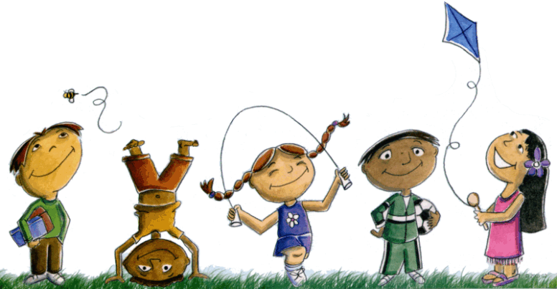

Read all Summer
- Keep track of your time.
- Win prizes!
- The more you read the more prizes you can win!
- Enter your name for prizes drawn at the end of the program.
- Last year kids read for a total of 196,034 minutes!
- Have fun at the library!

May 2023

Dear Parents,
Let’s keep the kids reading this summer! Just have a valid library card and register your children for the TD Summer Reading Program Club 2020. This program will help maintain and develop reading skills and provide an opportunity to meet new friends! Invite your friends, family, and neighbours to join in the fun!
Our TD Summer Reading Club theme for this year is ‘Check this Out!’ The action begins on July 4th at the Blackfalds Public Library with. Registration begins on June 29th. However, you will be able to register your child throughout the summer. The goal is to read at least fifteen minutes a day. Adults can also join in the excitement. Track your minutes and win prizes. Come in anytime to record your minutes or to join in the activities. There is always something fun to do! We have story time, crafts, games and special guests throughout the summer.
We appreciate your help in making our summer reading program a success. We are going to have a great summer!
Your Blackfalds’ Public Library.

